# CSA1523- CLOUD COMPUTING AND BIG DATA ANALYTICS FOR HEALTHCARE INDUSTRIES

**D.Hemalatha**

**192311107**

**EXP 4. Create a simple cloud software application for Car Booking Reservation System using any Cloud Service Provider to demonstrate SaaS.**

# AIM:

To Create a simple cloud software application for Car Booking Reservation System using any Cloud Service Provider to demonstrate SaaS.

# PROCEDURE:

STEP 1: Log in to ZOHO Creators and click Create a new application.

STEP 2: Choose from scratch and name the application (Ex-Car Booking Reservation System)

STEP 3: Create a new form as per the requirements. (Ex- User Registration form, Car Listing Form, Car Booking Form, etc)

STEP 4: Drag and place the required fields and click DONE.

STEP 5: Now open each module and give required details to store it in the report.

STEP 6: Verify the entries of User Registration form, Car Listing Form, Car Booking Form, etc from Module Reports.

STEP 7: The software has been created successfully.

# IMPLEMENTATION:

STEP1: Login to ZOHO Creators and click create a new application.

STEP 2: Choose from scratch and name the application (Ex-Car Booking Reservation System)

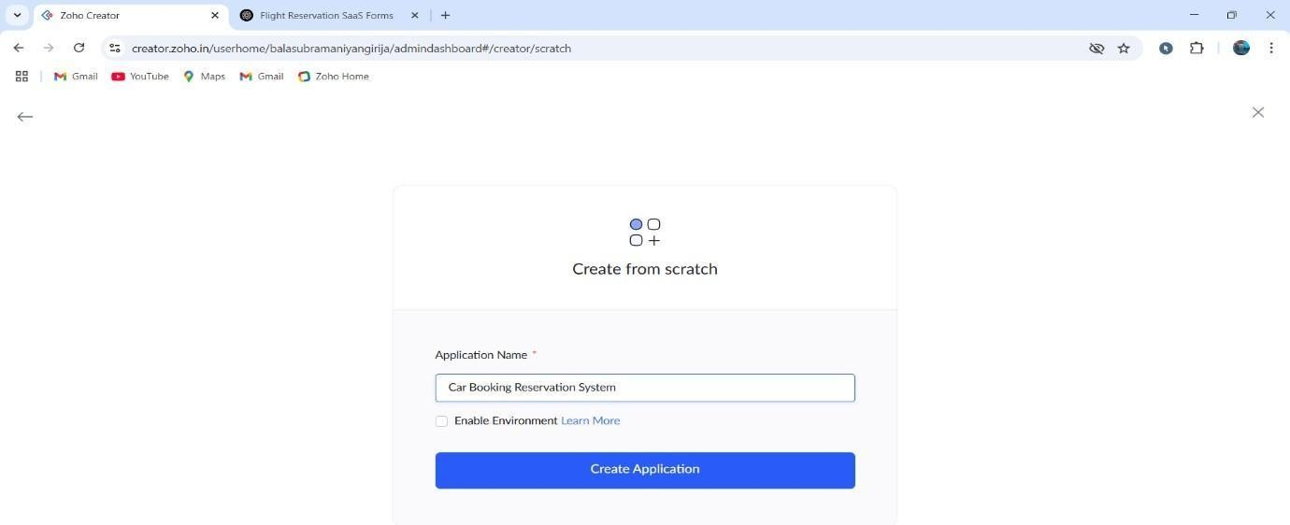

STEP 3: Create a new form as per the requirements. (Ex- User Registration form, Car Listing Form, Car Booking Form, etc)

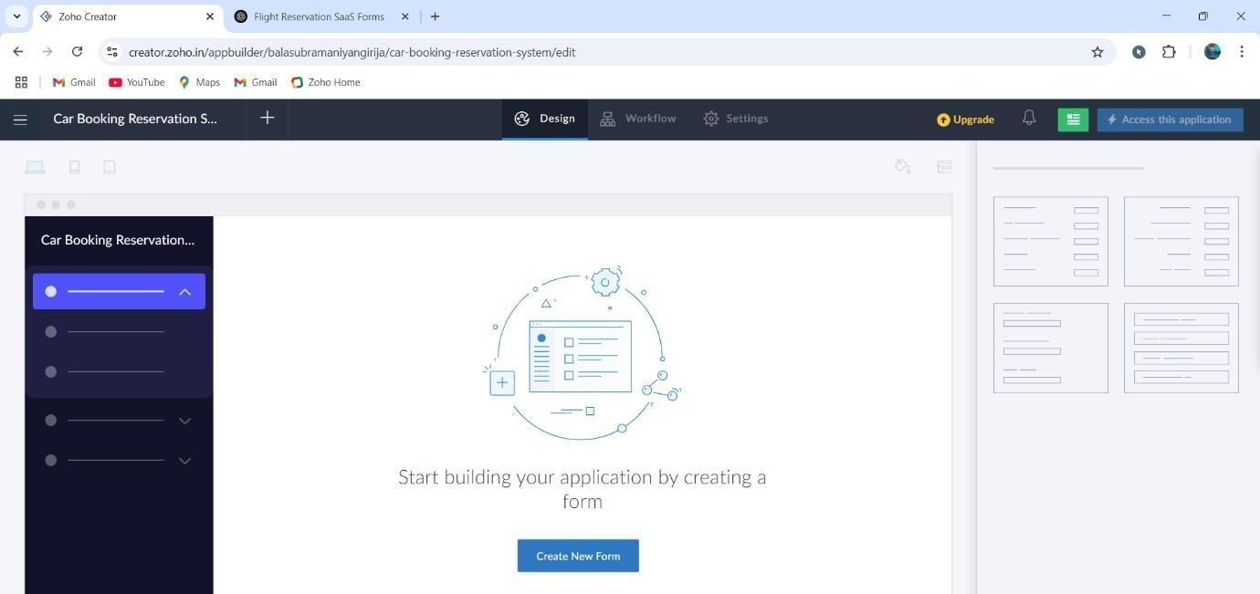

User Registration Form:

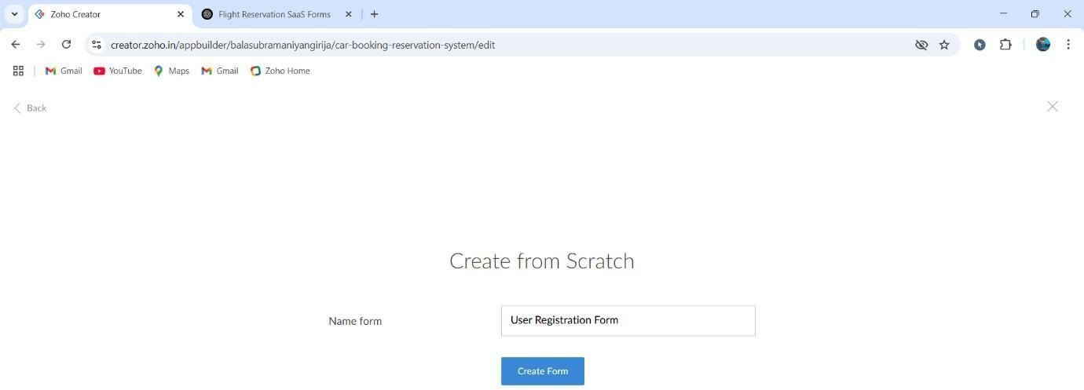

STEP 4: Drag and place the required fields and click DONE.

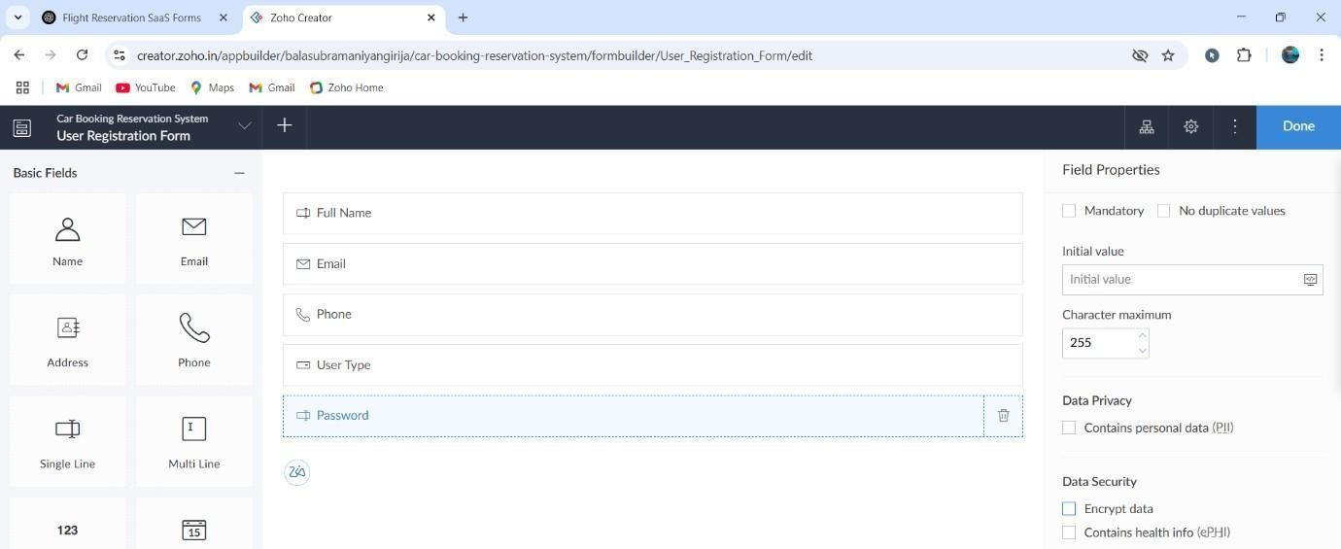

Follow these steps for all required forms: Car Listing Form:

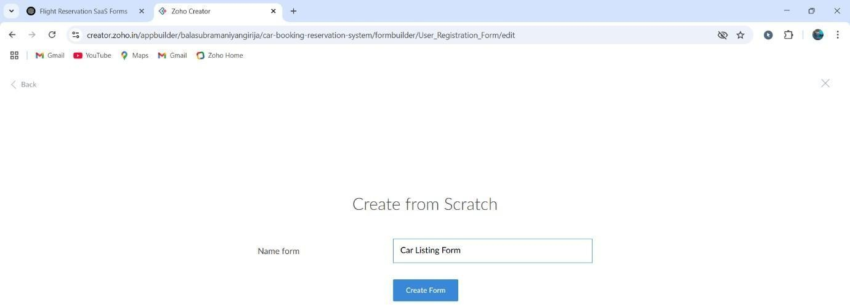

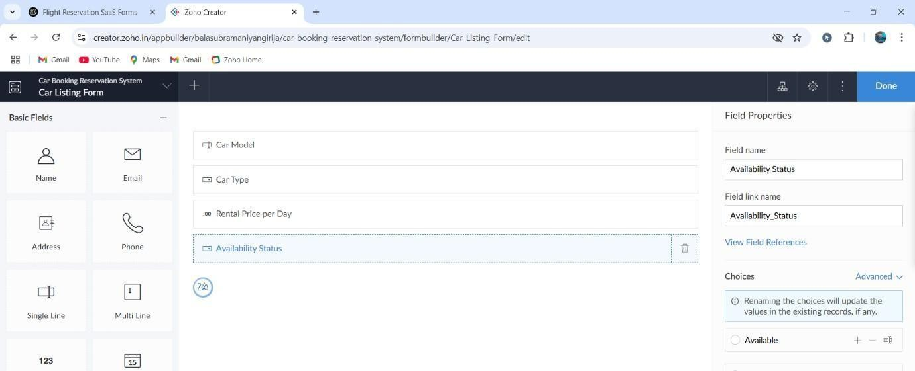

Car Booking Form:

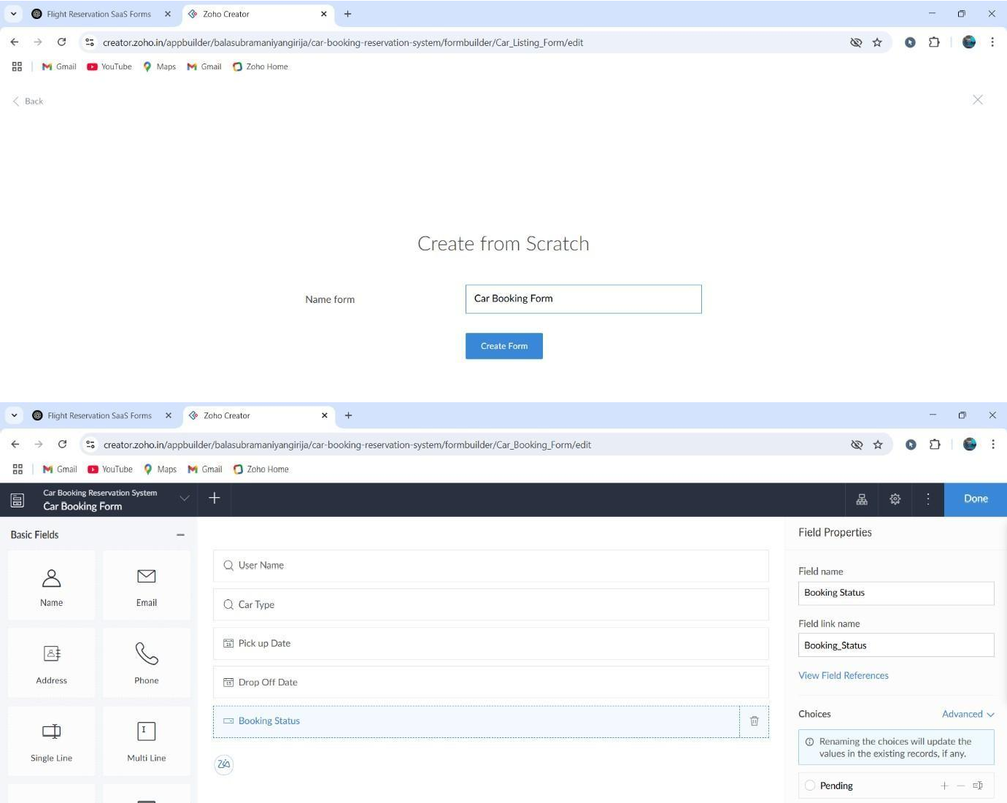

STEP 5: Now open each module and give required details to store it in the report.

User Registration form:

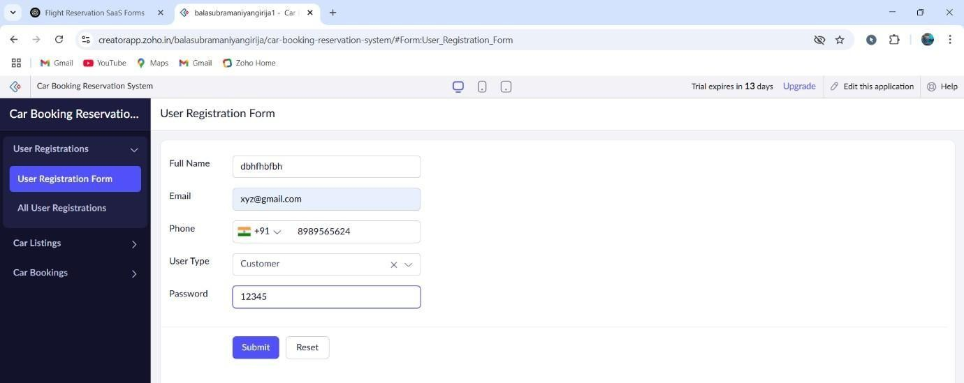

Car Listing Form:

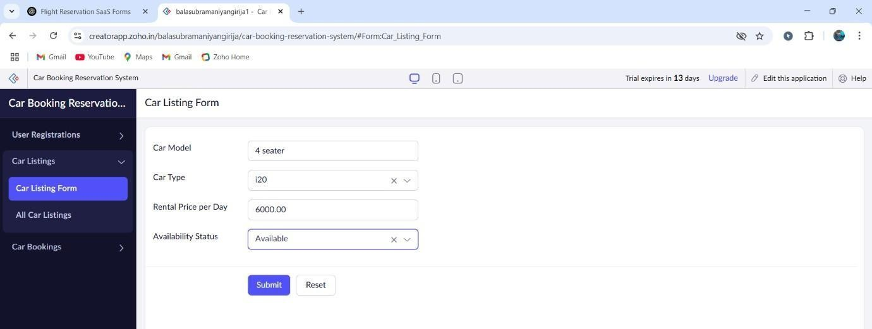

Car Booking Form:

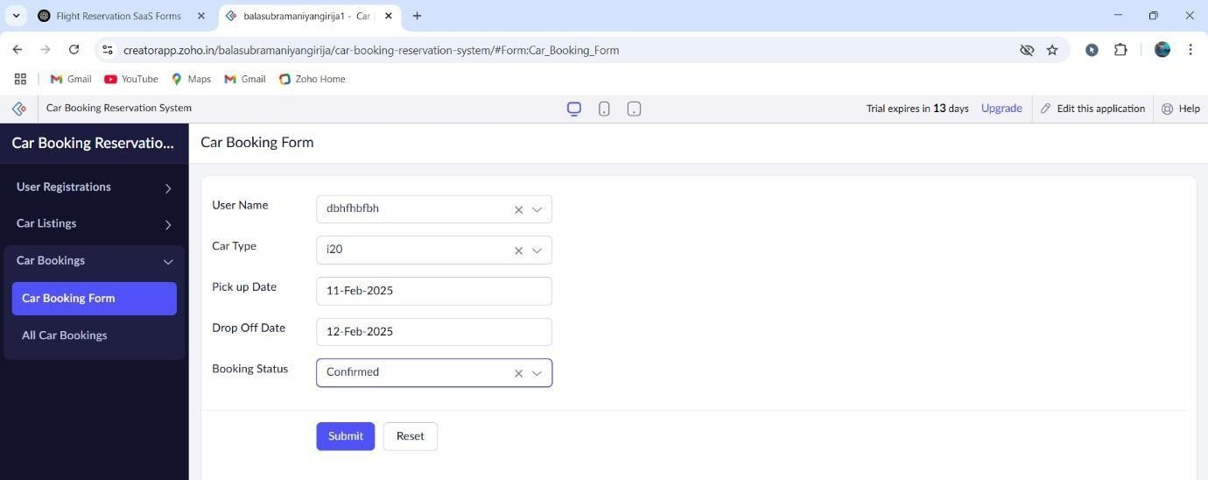

STEP 6: Verify the entries of User Registration form, Car Listing Form, Car Booking Form, etc from Module Reports.

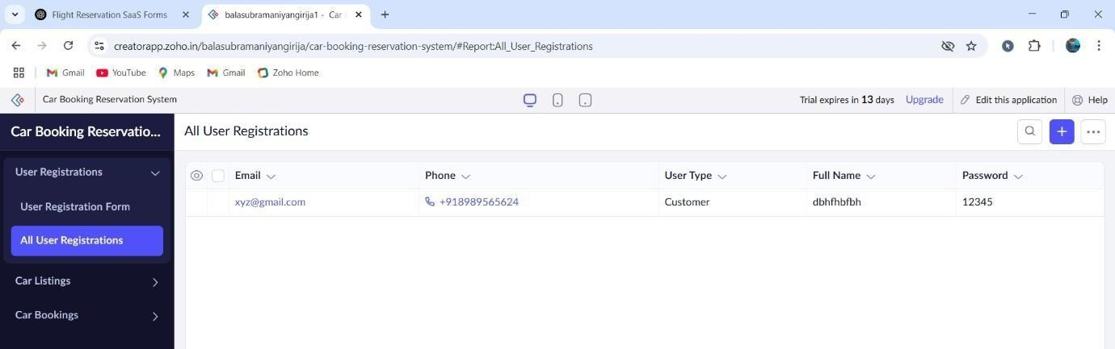

Car Listing Form:

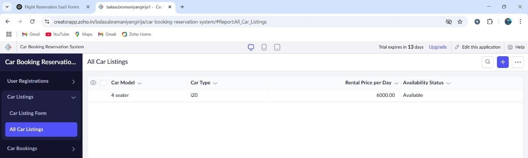

Car Booking Form:

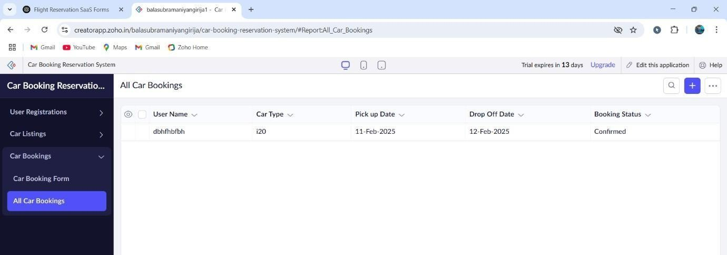

# RESULT:

The software has been created successfully.